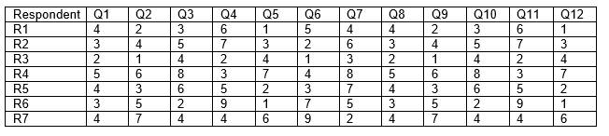

The above is the result table I generated from the responses given by each respondent.

In the table above R represents Respondent while Q represents question, then the numerics used to fill the table were the choices chosen as answers by the respondents. Like in Q1; respondent 1 gave “4” , respondent 2 gave “3” and it went that way until the last person who was respondent 7. Each of the choices given represented some range of values as in the questionnaire. Take a look at the table below, respondent 1 gave “4” as her answer but in the table 4 was a variable assigned to “Agree” this mean that she agreed that AI has reduced the use of resources in agriculture. This happens to all respondents who had given different answers and all of them are captured in the above table.

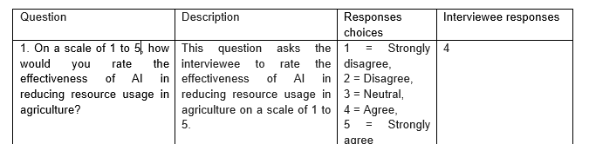

**How I drew the graphs**

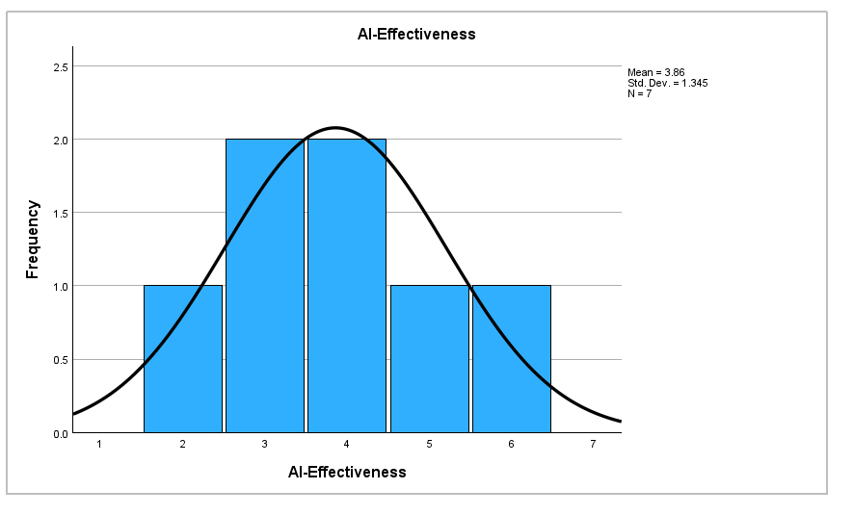

For the graph above, I used the responses given by the respondents on the question one as in the table above; the question was about the effectiveness of AI in agriculture. I then used the responses given against the respondents as the frequency and plotted a descriptive histogram above.